Topic: Percentages
EQ: How do we convert between fractions, decimals and percentages

As we know fractions, decimals and percentages are all closely linked and can be converted (changed) to be each other. So a fraction can be converted into a percentage and decimal, a percentage can be converted into a fraction or a decimal and a decimal can be converted into a percentage or fraction.

Before beginning the next section, there are some facts that you need to know. You have to learn this grid and just know the conversions.
Fraction | Decimal | Percentage
1  2 | 0.5 | 50%
1  4 | 0.25 | 25%
3  4 | 0.75 | 75%
1  5 | 0.2 | 20%
1  10 | 0.1 | 10%
Converting a fraction to a percentage
A percentage is part of 100.
If the fraction is (Something)
100
Then the number on the top is going to be the percentage, as it is that much out of 100.
E.g. 40 = 40%
100

However, for all other fractions this is what you do:
For example, if we had 4
25
We have to find a number that we can multiply 25 by to make 100, and then we have to multiply the numerator by the same number.
(x4)
So, 4 = 16 = 16%
25 100
(x4)

Converting a fraction to a decimal
To convert a fraction to a decimal we use our place value knowledge to help us.
Think of this: T U . t h th tth

If a denominator is 10, 100, 1000 you can use you place value knowledge, as you know what 10th’s, 100th’s and 1000th’s are.

For example: 3
10 is 3 10th’s and we know (from using the place value chart) that this is 0.3 as a decimal.

Similarly to converting a fraction to a percentage, if the denominator was not 10, 100 or 1000 we have to find a number that we can multiply the denominator by to make 100, and then we have to multiply the numerator by the same number.
(x4)
E.g 4 = 16 = 0.16
25 100
(x4)

Converting a percentage into a decimal
To convert a percentage to a decimal you divide the percentage by 100.

E.g. 68% = 68 ÷ 100 = 0.68

Converting a percentage into a fraction
To convert a percentage into a fraction, you put the number over 100 (as it is that amount out of 100) and then simplify the fraction if you can.
(÷5)
E.g. 65% = 65 = 13
100 20
(÷5)

Converting a decimal into a fraction
To convert a decimal you have to again use place value to help you.

First of all look at the decimal.
If the numbers in the decimal goes up to the 10th’s column then the answer is going to be that number over 10.
E.g. 0.8 = 8
10
If the numbers in the decimal goes up to the 100th’s column then the answer is going to be that number over 100.
(÷5)
E.g. 0.85 = 85 = 17
100 20
(÷5)
If the numbers in the decimal goes up to the 1000th’s column then the answer is going to be that number over 1000.
(÷2) (÷2) (÷2)
E.g. 0.848 = 848 = 424 = 212 = 106
1000 500 250 125
(÷2) (÷2) (÷2)

Converting a decimal into a percentage
To convert a decimal into a percentage you multiply the number by 100 and that is the percentage.

E.g. 0.32 = 0.32 ÷ 100 = 32 = 32%

You can also have an example like this:

0.625 = 0.625 ÷ 100 = 62.5 = 62.5%

Summary

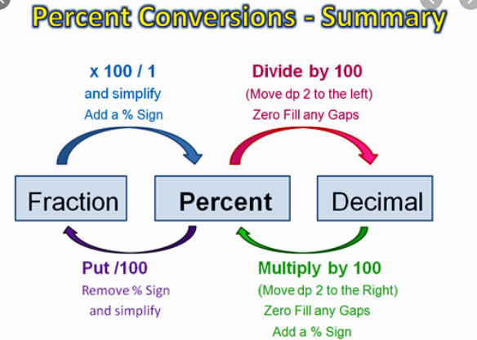

PERCENTAGE
FRACTION
DECIMAL

